**Batch: A4 Roll No.: 16010122083**

**Experiment / assignment / tutorial No_______**

|  |
| --- |
| **TITLE:**To study and implement Booth’s Multiplication Algorithm. |

**AIM:** Booth’s Algorithm for Multiplication

**______________________________________________________________________**

**Expected OUTCOME of Experiment: CO 1**

**_____________________________________________________________________**

**Books/ Journals/ Websites referred:**

1. Carl Hamacher, ZvonkoVranesic and SafwatZaky, “Computer Organization”, Fifth Edition, TataMcGraw-Hill.
2. William Stallings, “Computer Organization and Architecture: Designing for Performance”, Eighth Edition, Pearson.

3. Dr. M. Usha, T. S. Srikanth, “Computer System Architecture and Organization”, First Edition, Wiley-India.

**_____________________________________________________________________**

**Pre Lab/ Prior Concepts:**

It is a powerful algorithm for signed number multiplication which generates a 2n bit product and treats both positive and negative numbers uniformly. Also the efficiency of the algorithm is good due to the fact that, block of 1’s and 0’s are skipped over and subtraction/addition is only done if pair contains 10 or 01

**Flowchart:**

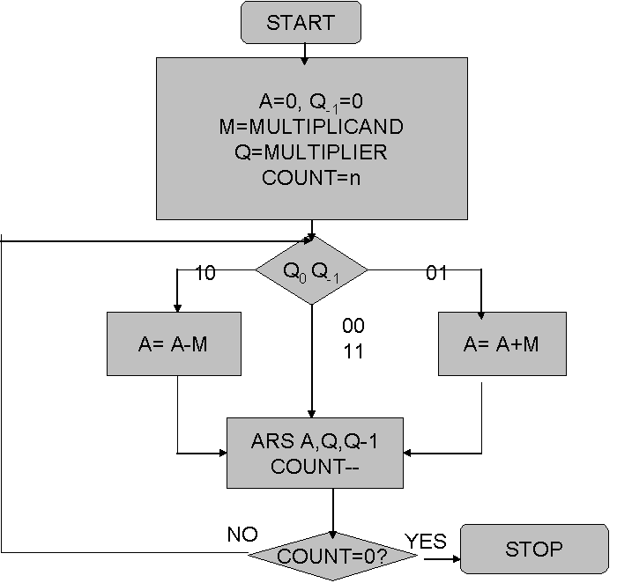

**Design Steps**:

1. Start
2. Get the multiplicand (M) and Multiplier (Q) from the user
3. Initialize A= Q-1 =0
4. Convert M and Q into binary
5. Compare Q0 andQ-1 and perform the respective operation.

|  |  |
| --- | --- |
| **Q0 Q-1** | **Operation** |
| 00/11 | Arithmetic right shift |
| 01 | A+M and Arithmetic right shift |
| 10 | A-M and Arithmetic right shift |

6. Repeat steps 5 till all bits are compared

7. Convert the result to decimal form and display

8. End

Example:

(Handwritten solved problem needs to be uploaded)

**Conclusion:**

**Post Lab Descriptive Questions**

1. **Explain advantages and disadvantages of Booth’s algorithm.**

**Advantages of Booth's Algorithm:**

Reduced Number of Additions: Booth's algorithm is a multiplication algorithm that reduces the number of partial product additions required during the multiplication process. This leads to a reduction in the overall number of operations and improves the efficiency of multiplication.

Faster Multiplication for Multi-Bit Numbers: Booth's algorithm is particularly efficient when multiplying multi-bit numbers, especially when one of the operands has a high number of '1's in its binary representation. It leverages the concept of recoding to effectively skip unnecessary additions, speeding up the multiplication process.

Simplicity of Hardware Implementation: Booth's algorithm can be implemented using a simple hardware circuit that involves shift and add operations. This makes it suitable for hardware implementations in processors and digital circuits.

**Disadvantages of Booth's Algorithm:**

Complexity for Small Operands: Booth's algorithm might not be efficient for small operands due to the overhead of setting up the initial recoding and handling the algorithm's steps. For small numbers, traditional multiplication methods might be simpler and faster.

Additional Hardware Complexity: While Booth's algorithm has advantages in terms of reducing the number of additions, its hardware implementation can be slightly more complex than traditional multiplication algorithms like "shift-and-add." This complexity can impact chip design and production costs.

Limited Applicability: Booth's algorithm is most effective when dealing with operands that have specific patterns in their binary representation. It might not be as advantageous when dealing with operands that don't exhibit these patterns, leading to reduced performance gains.

1. **Is Booth’s recoding better than Booth’s algorithm? Justify**

Booth's recoding is a technique used as part of Booth's multiplication algorithm. It involves transforming one of the operands into a recoded version that simplifies the multiplication process by minimizing the number of additions required. The recoding helps identify areas where addition can be avoided.

Booth's recoding and Booth's algorithm are not directly comparable in terms of being better or worse than each other. Booth's recoding is a critical component of Booth's algorithm; it's not an alternative method but rather a technique used within the algorithm. In other words, Booth's recoding is an integral part of Booth's algorithm's efficiency improvements.

Booth's algorithm, when applied with Booth's recoding, can offer advantages in terms of reducing the number of additions required during multiplication. The recoding step optimizes the multiplication process for specific operand patterns. Therefore, it wouldn't make sense to compare Booth's recoding against Booth's algorithm since the recoding technique is part of the overall algorithm.

In summary, Booth's recoding enhances the efficiency of Booth's algorithm by reducing the number of additions required, and this combination can be beneficial for efficient multiplication of multi-bit operands with specific binary patterns.

**Date: _____________**